

JOB DESCRIPTION and PERSON SPECIFICATION

SERVICE AREA: | Hull Citysafe | POSITION NO:
SECTION: | Neighbourhood Nuisance Team (NNT) | GRADE: 3
JOB TITLE: | Neighbourhood Nuisance Assessment Assistant | DATE PREPARED: September 2010 (reviewed July 2023)
EVALUATION DATE: | 12th October 2010 (reviewed July 2023) | JE NUMBER: NC691
DIGNITY AT WORK:

To show, at all times, a personal commitment to treating all customers and colleagues in a fair and respectful way, which gives positive regard to people’s differences and individuality (for example, gender, gender identity, nationality or ethnic origin, disability, religion or belief, sexual orientation, age). Assists in ensuring equal access to services and employment opportunities for everyone and promotes the Council’s Equal Opportunities in Employment Policy.

PURPOSE:

To provide an efficient, responsive, high quality technical and general clerical service to staff of the Neighbourhood Nuisance Team (NNT) and in particular responding to requests from the public via the Council’s Call Centre and online reports and entering service requests on the anti-social behaviour recording system.

To work within a small team of administration support, sharing knowledge of duties to ensure continual cover is provided Monday to Thursday 8.30 am – 5.00 pm and Friday 8.30 am – 4.30 pm by a team of Neighbourhood Nuisance Assessment Officers. To effectively contribute to the input and maintenance of computer data, take service requests by telephone and in person at reception, to process inward and outward correspondence, produce statistics for management information, provide administrative support and to maintain tidy, accurate filing systems.

To be an agile worker and work at various locations across the city.

PRINCIPAL ACCOUNTABILITIES:
Please note decision making must be included within the Principal Accountabilities
1. | Providing a first point of contact with the Neighbourhood Nuisance Team, assessing and prioritising all cases of neighbourhood nuisance ensuring correct level of response and signposting to other agencies.
2. | Provide a courteous and responsive service to telephone and personal enquiries (service requests), entering relevant data on computer and ensuring service requests are referred to the appropriate officer/section.
3. | Maintain and update specific databases, inputting and extracting data and assisting with the validation of data. Also interrogate other Council systems.
4. | Accurately maintain the Neighbourhood Nuisance Team’s electronic filing system involving the creation, updating, indexing, tracking, retrieval, archiving and destruction in accordance with statutory and departmental requirements.
5. | Make effective use of information technology and available computer software and equipment to achieve a progressive and professional service for the section. Management of the team’s noise monitoring equipment (DAT’s).
6. | Provide an efficient, effective and responsive general administrative support service to the staff of the Neighbourhood Nuisance Team. Help with the co-ordination of tasking and tiered lists across the city.
7. | Access and provide statistics for management, including reports and customer satisfaction statistics, when required.
8. | Efficiently and effectively process incoming and outgoing correspondence of the Neighbourhood Nuisance team, including amending service requests transferred from the Oracle to the Flare computer system.
9. | Use the Council’s Oracle procurement system in relation to ordering, purchase orders and invoices.
10. | To support Anti-Social Behaviour Officers by attending community engagements events across the city.
11. | The Health and Safety at Work Act 1974 and associated legislation places responsibilities for health and safety on Hull City Council, as your employer and you as an employee of the Council. In addition to the Council’s overall duties, the post holder has personal responsibility for their own health, safety and wellbeing and that of other employees; additional and more specific responsibilities are identified in the Council’s Corporate H&S policy.
GENERAL:

The above principal accountabilities are not exhaustive and may vary without changing the character of the job or level of responsibility. The postholder must be flexible to ensure the operational needs of the Council are met. This includes the undertaking of duties of a similar nature and responsibility as and when required, throughout the various workplaces in the Council.

DIMENSIONS:
All sections should be completed – if there aren’t any state ‘none’
1. Responsibility for Staff:

None.

- Responsibility for Customers/Clients:

The post holder will:

- Be the first point of contact for customers and clients.
- Assess and prioritise individual cases, sign postings to other agencies where appropriate.
- Provide general clerical and administration support for up to 19 Anti-Social Behaviour Enforcement Officers, NNT Leaders & NNT Manager
- Ensure customers’ and clients’ service requests are directed efficiently and effectively to the relevant Officer/Section.
- Offer support and advice to internal and external customers and clients.

3. Responsibility for Budgets:

None.

4. Responsibility for Physical Resources:

The post holder will be responsible for daily housekeeping of office equipment, CCTV systems and noise monitoring equipment.

WORKING RELATIONSHIPS:
All sections should be completed – if there aren’t any state ‘none’

1. Within Service Area/Section:

Regular liaison with departmental staff, especially Anti-Social Behaviour Officers and
Team Leaders. Also, staff from the Environmental Protection, Housing, Domestic Abuse
Partnership, Humberside Police, Hull Youth Justice Service and Early Help.

2. With Any Other Council Areas

Other Departments within the Council including Councillors, Benefits and Housing teams and area teams for general advice. Regular contact with the Call Centre.

3. With External Bodies to the Council

Deals with enquiries from external organisations, members of the public, which
may be of a confidential and sensitive nature.

 | ORGANISATION CHART:
 | 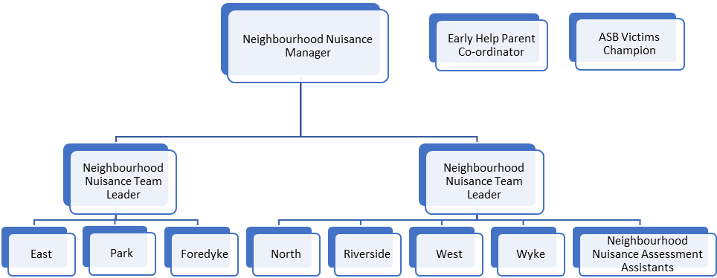
 |  | Tick relevant level for each category
 |  | Not applicable | Low | Moderate | High | Very High | Intense | Supporting Information  (if applicable)
PHYSICAL DEMANDS:  Physical Effort and/or Strain – (tiredness, aches and pains over and above that normally incurred in a day-to-day office environment). |  | X
WORKING CONDITIONS:  Working Conditions – (exposure to objectionable, uncomfortable or noxious conditions over and above that normally incurred in a day-to-day office environment). |  | X
EMOTIONAL DEMANDS:  Exposure to objectionable situations over and above that normally incurred in a day-to-day office environment. |  |  |  | X |  |  |  | Dealing frequently with victims and witnesses of ASB in an emotionally charged state on a daily basis.

PERSON SPECIFICATION |  |  | Tick relevant column |  | List code/s*
The information listed as essential (the column that is shaded) is used as part of the job evaluation process. The requirements identified as desirable are used for recruitment purposes only.  *Codes: AF = Application Form, I = Interview, CQ = Certificate of Qualification, R = References (should only be used for posts requiring CRB’s), T = Test/Assessment, P = Presentation |  |  | Essential | Desirable | How identified
1. | Qualifications:
1. | Good standard of general education including good applied literacy and numeracy skills |  | X |  | AF/CQ
1. | Must be committed to attending and undertaking training |  | X |  | I
1. | 4 GCSE’s (Level 4, previously Grade C or above) or equivalent English Language and Mathematics |  |  | X | AF/CQ
2. | Relevant Experience:
2. | Previous experience of working in an office/administrative environment |  | X |  | AF/I/R
2. | Experience of IT and database applications |  | X |  | AF
2. | Experience of general administrative procedures and experience of dealing with the general public over the telephone |  | X |  | AF
2. | Experience of dealing effectively with members of the public and other departments & agencies |  | X |  | AF/I/R
2. | Experience of working with call centre |  |  | X | AF/I/R
3. | Skills (including thinking challenge/mental demands):
3. | Must be able to work independently and use own initiative while also being a member of a team |  | X |  | AF/R
3. | Ability to plan and prioritise own work |  | X |  | AF
3. | Meet strict deadlines |  | X |  | AF
4. | Knowledge:
4. | Must have practical knowledge of IT |  | X |  | AF/I
4. | Knowledge of technical and legal terminology in relation to anti social behaviour |  |  | X | AF/I
5. | Interpersonal/Communication Skills:  Verbal Skills
5. | Courteous telephone and personal manner |  | X |  | AF/I/R
5. | Basic tact, diplomacy and helpfulness dealing with customers and clients. Also, to have the skills to challenge and influence. |  | X |  | AF/I/R
5. | Acts as a first point of contact to a diverse range of customer and client enquiries and must be able to deal with these enquiries appropriately and sensitively |  | X |  | AF/I/R
5. | Written Skills
5. | Initiating routine written, email correspondence and reports |  | X |  | AF/I/R
6. | Other:
6. | None |  |  | N/A
The requirements listed below are not considered during the job evaluation process but are essential requirements for the role that will be assessed during the recruitment process.
7. |  | Values and Competencies:
 |  | The values and competencies listed below are all essential requirements for working at Hull City Council in any post; however, those that have been ticked as essential have been identified as key for this role and will be measured as part of the selection process. They are not required to be addressed in your application form.
 |  | Values:
 |  | People First | X |  | I
 |  | Respect | X |  | I
 |  | Learning | X |  | I
 |  | Ambition | X |  | I
 |  | Partnership | X |  | I
 |  | A copy of the Council’s Values and Behaviours can be accessed via the Council’s website – www.hullcc.gov.uk/jobs
 |  | Competencies:
 |  | Leading forward |  | N/A
 |  | Improving services | X |  | I
 |  | Analysis and decision making |  | N/A
 |  | Making things happen | X |  | I
 |  | Communicating with impact | X |  | I
 |  | Collaboration | X |  | I
 |  | Developing self and others | X |  | I
 |  | A copy of the Competency Framework can be accessed via the Council’s website – www.hullcc.gov.uk/jobs
8. |  | Additional Requirements:
 |  | Cross as an essential requirement if the candidate requires a Baseline Personnel Security Check (BPSS) |  | N/A
9. |  | Disclosure of Criminal Record:
 |  | The successful candidate’s appointment will be subject to the Council obtaining a satisfactory Enhanced Disclosure from the Disclosure and Barring Service (if ticked as an essential requirement). | X |  | DBS Disclosure
 |  | If the postholder requires a Standard or Enhanced DBS disclosure (with or without barred list check) the candidate is required to declare full details of everything on their criminal record. | X |  | AF (after short listing)
 |  | If the postholder does not require a DBS disclosure, or requires a Basic Disclosure check only, the candidate is required to declare unspent convictions only. |  | N/A | AF (after short listing)

